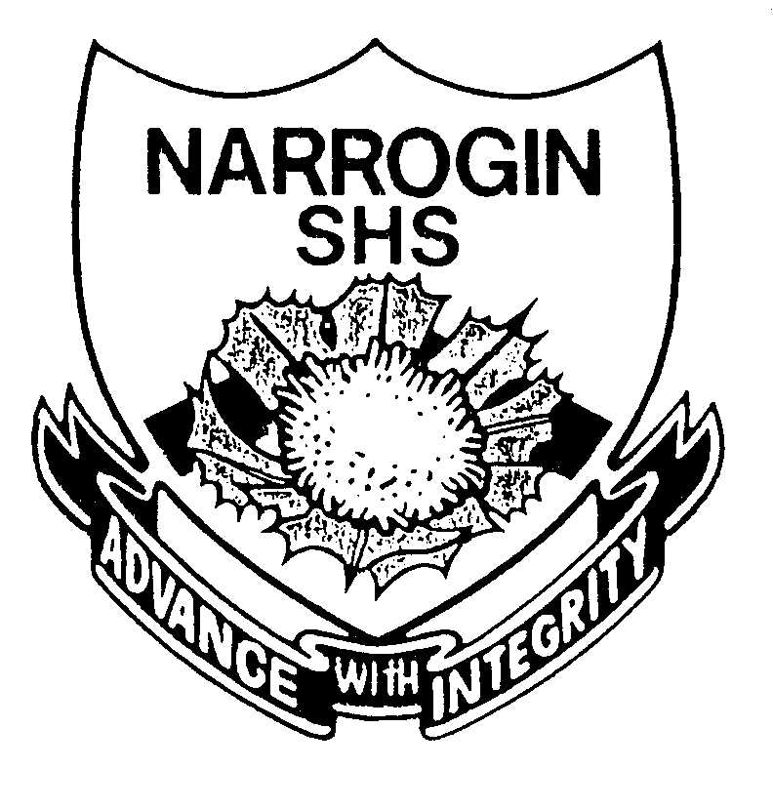

NARROGIN SHS

Year 11

SECOND SEMESTER EXAMINATION 2002

HISTORY DOCUMENT BOOKLET

Document Set 1: Investigating Fascism – Nazi Germany

Source 1

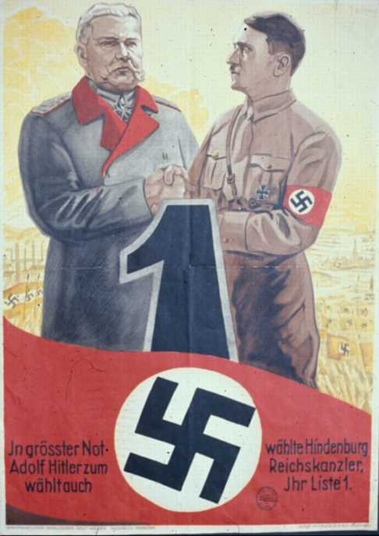

A March 1933 election poster. The text: "In the deepest need Hindenburg chose Adolf Hitler for Reich Chancellor. You too should vote for List 1."

Source 2

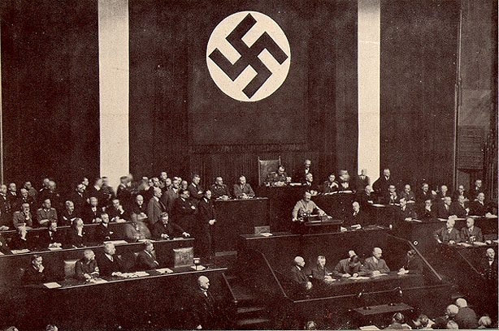

Caption: "The way is open for the people's chancellor Adolf Hitler's work of reconstruction. The Reich Chancellor presenting the case for the Enabling Act to the Reichstag on 23 March 1933. It passed with an overwhelming majority vote of 441 to 94."

The Source: Wilhelm Köhler, Die nationale Revolution in Deutschland. Ein Gedenkbuch in Bildern (Minden: Druck und Verlag von Wilhelm Köhler, 1933).

Source 3

On 25 February 1934, about a million Nazi party officials gathered at points around Germany to swear an oath to Adolf Hitler. This is an excerpt from the speech Rudolf Hess gave on the occasion, which was broadcast to the nation.

Political leaders! Leaders of the Labor Service, the forces of labor! Women's leaders, HJ leaders! Leaders of the BDM! You will now take an oath to Adolf Hitler!

Your oath is not a mere formality; you do not swear this oath to someone unknown to you. You do not swear in hope, but with certainty. Fate has made it easy for you to take this oath without condition or reservation. Never in history has a people taken an oath to a leader with such absolute confidence as the German people have in Adolf Hitler. You have the enormous joy of taking an oath to a man who is the embodiment of a leader.

You take an oath to the fighter who demonstrated his leadership over a decade, who always acts correctly and who always chose the right way, even when at times the larger part of his movement failed to understand why, You take an oath to a man whom you know follows the laws of providence, which he obeys independently of the influence of earthly powers, who leads the German people rightly, and who will guide Germany's fate. Through your oath you bind yourselves to a man who — that is our faith — was sent to us by higher powers. Do not seek Adolf Hitler with your mind. You will find him through the strength of your hearts!

Adolf Hitler is Germany and Germany is Adolf Hitler. He who takes an oath to Hitler takes an oath to Germany!

Source 4

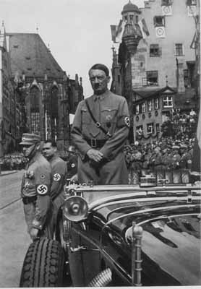

A proud Führer reviews parading Storm Troopers at the Nuremberg Party rally. 1934

Source 5

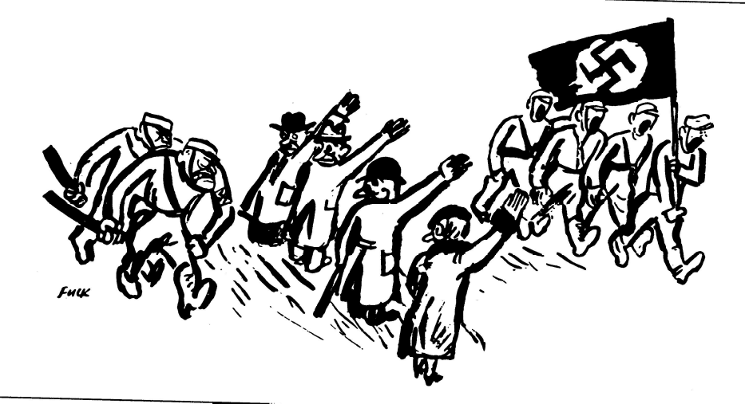

“Popular Enthusiasm”
A cartoon from the 1980’s

Source 6

At age 14 the youth in Nazi Germany participated in a ceremony symbolising their increasing independence and maturity. The following extract forms part of a speech to be given at all these youth ceremonies as stipulated by the Nazi Party. Believed to have been written around 1939.

…Never forget, boys and girls, that you live today in a free and strong Germany, and that your future will be secure only if you preserve this spirit of community. Before Adolf Hitler, your parents and grandparents of the German community were divided into classes and groups, and Germany was defeated. Back then, someone who got his hands dirty by working honestly and industriously for his people was held in contempt by those who earned their money in other ways. German boys and girls, you must never again let Germany be divided into classes and groups, into parties and religious denominations. The community you had as Pimpfe or Young Girls you must also have as members of the Hitler Youth or the League of German Girls, and further on when you put on the uniform of the Labor Service, the army, the SA, the SS, the NSKK, or the NS Flying Corps. You must have it even later when you become a political leader or a member of the Women's League so that alongside your work or household you can carry on the work of Adolf Hitler, even when the day comes that the Führer is no longer with us.

You must be comrades for your entire life, and must respect every citizen who works, or who as a soldier is ready to give his life for Germany, and you must yourself strive to become such a worker or soldier. The life before you is not a matter of good or bad behaviour, or parental punishment, or cowardly behavior to avoid parental punishment, rather it is a matter of proving yourself as a man or a woman…

Pimpf = members of the youth group for young boys

Source 7

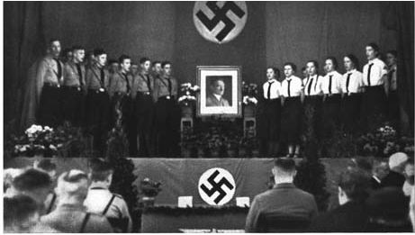

A photo, issued to organisers of these Nazi Youth Ceremonies, as an example as to how the room should be set out, where people should be seated and organisation of Nazi Movement symbols. (1939)

Source 8

The following prayer was written my Nazi leader, Baldur von Shirach and was required to be said by members of the Hitler Youth before meals.
Fuehrer, my Fuehrer given me by God,
Protect and preserve my life for long.
You rescued Germany from its deepest need.
I thank you for my daily bread.
Stay for a long time with me, leave me not.
Fuehrer, my Fuehrer, my faith, my light
Hail my Fuehrer.

Source 9
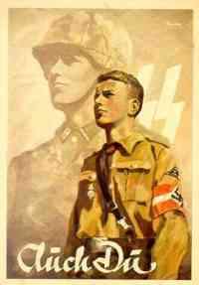
Hitler Youth Propaganda Poster

Document Set 2: Investigating Fascism – Nazi Germany

Source 1

Der Giftpilz, the German word for toadstool, was a publication of Julius Streicher's publishing house. It was aimed particularly at kids, and was sometimes used in the schools. Source: Ernst Hiemer, Der Giftpilz (Nuremberg, Stürmerverlag, 1938).

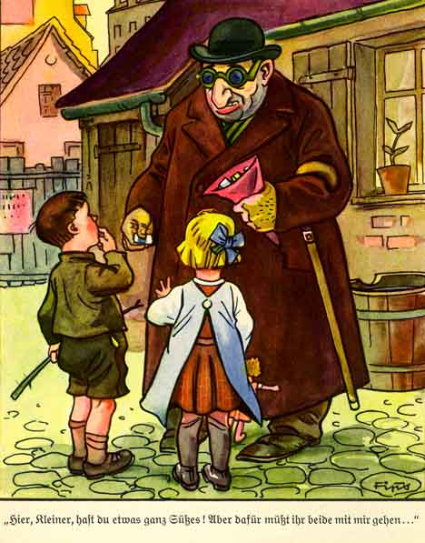

The Experience of Hans and Else with a Strange Man:

"Here, kids, I have some candy for you. But you both have to come with me..."

Source 2

The following article appeared in Der Stürmer (the Nazi’s own newspaper) in July 1933, soon after Hitler took power.

…The Jew miscalculated. The spiritual hero did not come too late. He took up battle with Pan-Jewry and won the victory. The world knows the name of this hero. He is Adolf Hitler, the Führer of the German freedom movement. The Jew sank under his blows in the dust. Now he sees the enormous danger he faces. He has been uncovered, his criminal plans have been discovered, and a battle is coming like the world has never seen. World Jewry faces Adolf Hitler. World Jewry faces Germany. The Jews will fight without pity. We must also fight without pity against Pan-Jewry. The Jewish people is the people of the Devil. It is a people of criminals and murderers. The Jewish people must be exterminated from the face of the earth.

